**MINISTRY CATEGORY-** *MINISTRY OF WOMEN AND CHILD DEVELOPMENT*

**PROBLEM STATEMENT-** *PORTAL FOR CHILD CARE INSTITUTIONS*  **PROBLEM CODE-** #*MWC8*

**TEAM LEADER NAME-** *BHUVNESH KUMAR***COLLEGE CODE-***1-3330347904*

**IDEA OF APPROACH**

|  |  |
| --- | --- |
| RESPECTIVE DEPARTMENTS | ACCESSIBILITY |
| * The Child Care Institution (CCI)- | * Enter data of the children/staff on the regular basis. * Mark attendance * View information of children/staff with their attendance and cases (pending/ complete). |
| * The Child Welfare Committee (CWC)- | * View information of children/staff with their attendance and cases (pending/ complete). * View pendency list and sitting details. * Enter sitting details and its consequences in DB. |
| * Public- | * View children’s information. * Register a complaint of missing child * Report of sighted/found child |
| * Police- | * Create case for child found who is lost * View cases * Online complaint of missing child (when parents prefer offline mode) |
| * The District Magistrate (DM)- | * View information of children/staff with their attendance and cases (pending/ complete). * Take action using the information of the child/staff or the pending cases (if required). |
| * The District Child Protection Unit (DCPU)- | * View information of children/staff with their attendance and cases (pending/ complete) (if required). * View pendency list and sitting details. * Release funds using the information of the child/staff or the pending cases (if required). |
| * The Government- | * **State government**- * View information of children/staff with their attendance and cases (pending/ complete). * **Central government**- * View information of children/staff with their attendance and cases (pending/ complete). |

* **This table above shows the accessibility of the portal based information to the different departments respectively. A very neat update of the portal will be done by the respective authorities on the regular basis. Additionally, fingerprints will be taken on the daily basis for the attendance purposes of the children and image recognition will be done when searching process is in action, comparisons will be made with the information of the existing children.**
* **Technically speaking, the portal is accessible to the nation in a number of ways so that the recognition of these kids can be done on a much faster pace. Proper records regarding the children, the departments and the other respective committees will be kept so that linking and verification of data can be done more appropriately. Furthermore, it will be made possible for the action making & taking departments to have clear information before taking any major step.**
* **A flexible justice with the children away from their homes will be done once all the related data including his/her background is collected and verified accordingly. In case people apply for any search filters, they will get notified for the missing kids found in and around their respective locations and hence they can easily access the database; otherwise they are free to explore. The main motive behind this particular software development is- A clean and transparent functioning of the different committees can take place regarding every aspect related to this particular issue, may it be the funding procedure, the cases, the new case filing etc.**
* **A more transparent functioning is one thing that every citizen can trust. Keeping in mind, a step further can change several lives; the software has been brought up in action.**

**TECHNOLOGY STACK**

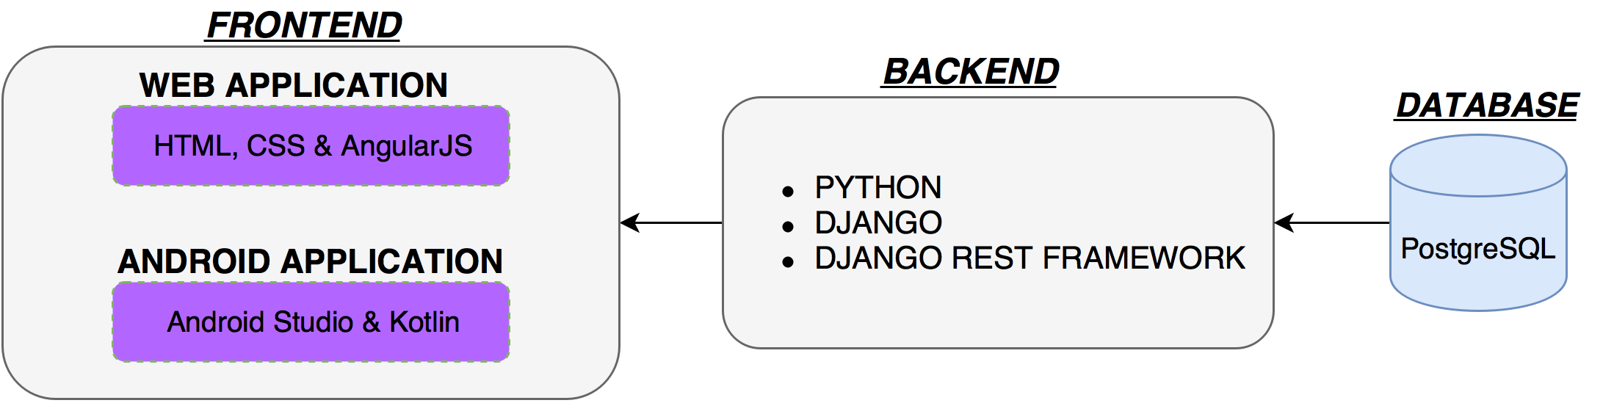

**USE CASE**

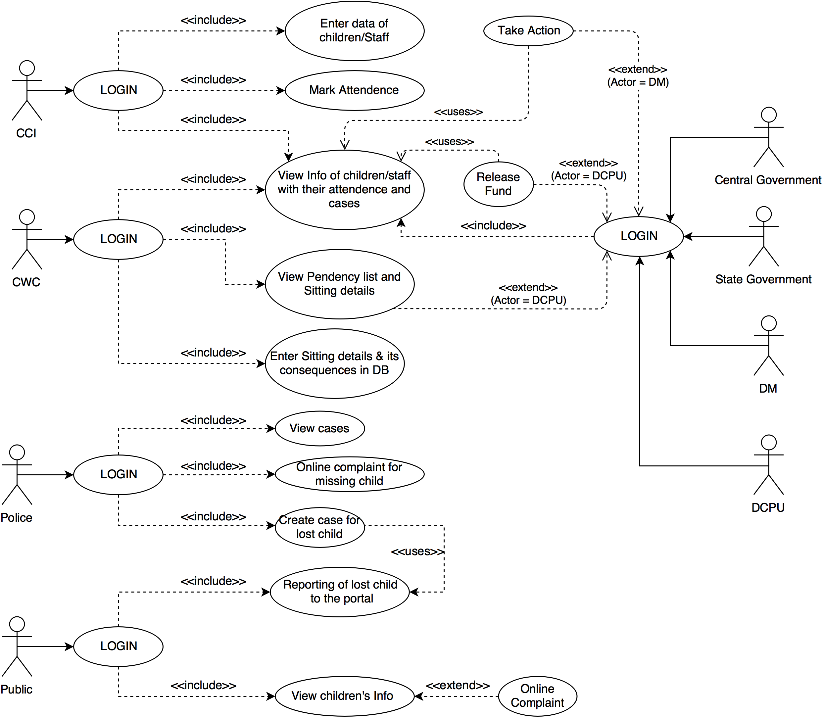

**DEPENDENCIES**

* **OpenCV Library** (for Image and fingerprint recognition)
* **Fingerprint scanner**
* **Web Cam**

**ACTIVITY DIAGRAM**

